18.58: The density 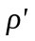 of the hot air must be 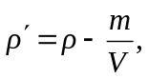 where is the density of the ambient air and m is the load. The density is inversely proportional to the temperature, so

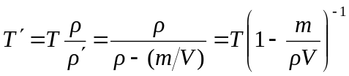

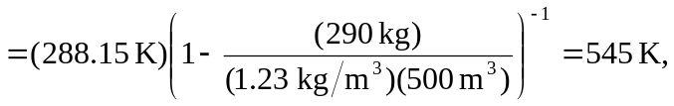

which is 